Setup dock9/ocr load balancing environment with Kunernetes cluster

# **Install Docker and Rancher to manage Kubernetes cluster and docker**

## Install Docker

Rancher requires one of the following Docker versions:

* 17.03.2

After the login via ssh we proceed as follows:

## Update The Package Index:

sudo apt-get update

## Install The Packages That Allow Accessing A Repository Via Https:

sudo apt-get install \  
 apt-transport-https \  
 ca-certificates \  
 curl \  
 Software-properties-common

## Add The Docker GPG Key:

curl -fsSL https://download.docker.com/linux/ubuntu/gpg | sudo apt-key add -

## Update The Package Index:

sudo add-apt-repository \  
 "deb [arch=amd64] https://download.docker.com/linux/ubuntu \  
 $(lsb_release -cs) \  
 stable"

## Updating The Package Index Again:

sudo apt-get update

## List The Docker Versions Available In The Repository:

sudo apt-cache madison docker-ce

## Install Docker In Version 17.03.2

sudo apt-get install docker-ce=17.03.2~ce-0~ubuntu-xenial

## Start The Rancher Container

sudo docker run -d --restart=unless-stopped -p 8080:80 -p 8443:443 rancher/rancher

## Configure Rancher

Now we can access the running Rancher server at **https://<ip_address>**.

For example: **https://192.155.90.60:8443**

## Add The ProfitBricks Driver

To add the ProfitBricks Docker Machine Driver, click on "Node Driver" and then on "Add Node Driver".

In the now open mask, we enter the following URL and then click on "Create".

https://github.com/profitbricks/docker-machine-driver-profitbricks/releases/download/v1.3.3/docker-machine-driver-profitbricks-v1.3.3-linux-amd64.tar.gz

The ProfitBricks Docker driver is downloaded and automatically set to active.

# **Create a cluster**

1. In the menu click on "Clusters", then on "Add Cluster"

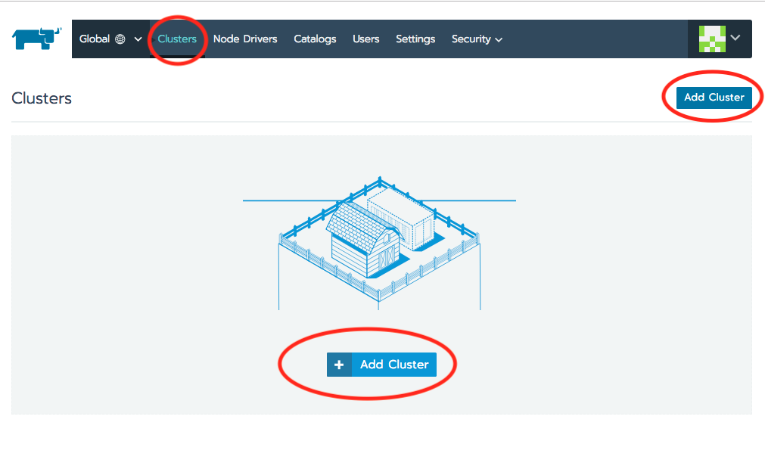

1. select custom cluster and enter values:

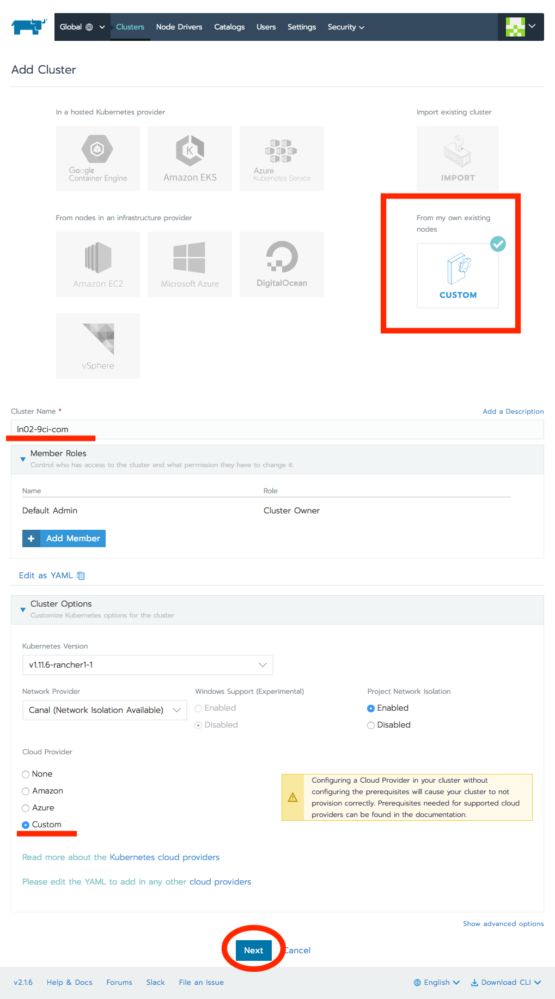

1. After check Node options, copy docker command and run it on server console

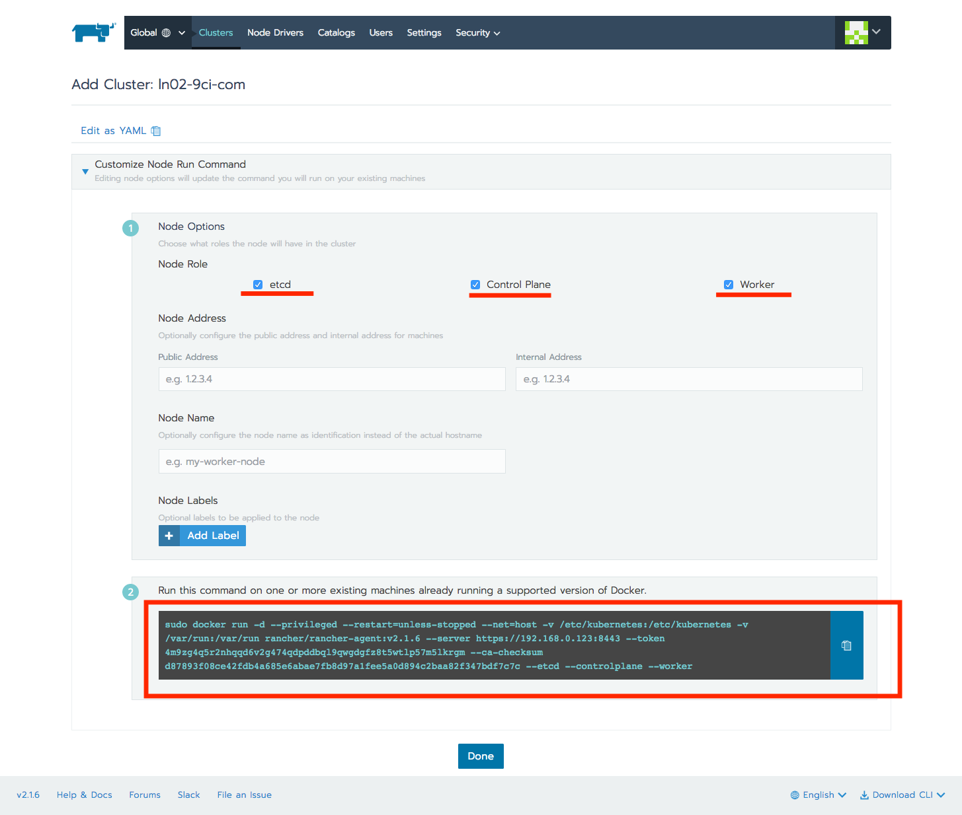

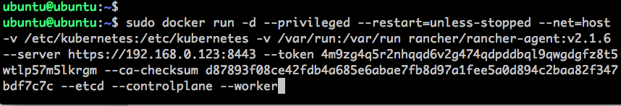

1. Click the page “Done” button. Then you can see this image. You need to wait until complete on the page. It maybe take for about 20 mins.

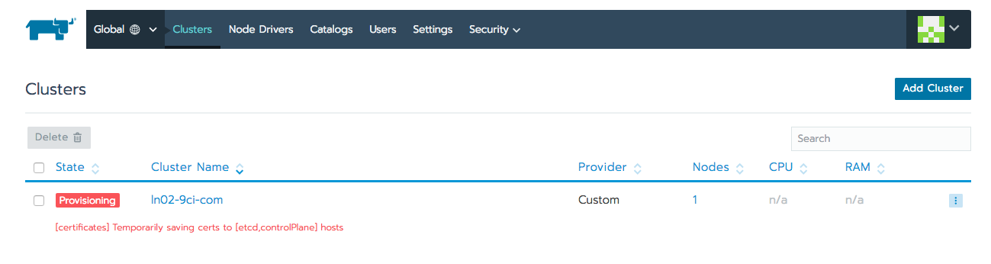

# **Create storage class**

1. Add new class

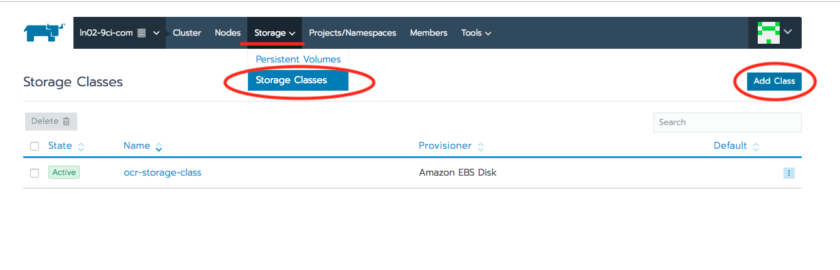

1. Setup values and save

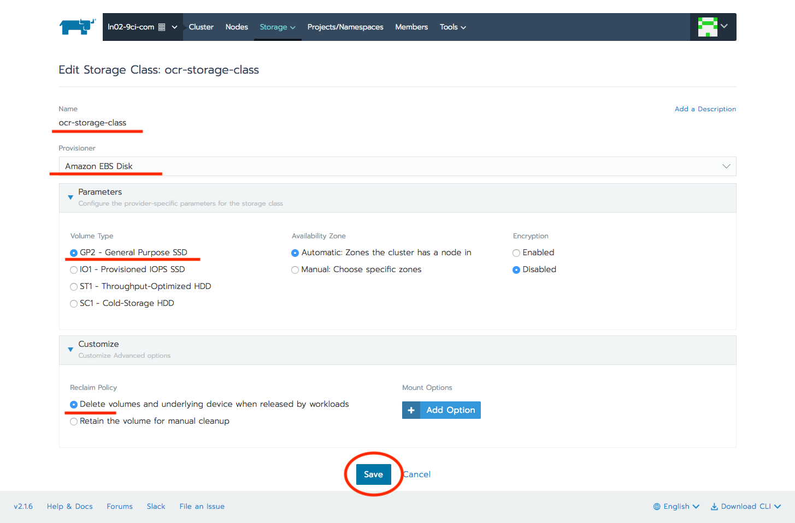

# **Create persistent volumes**

1. Add new class

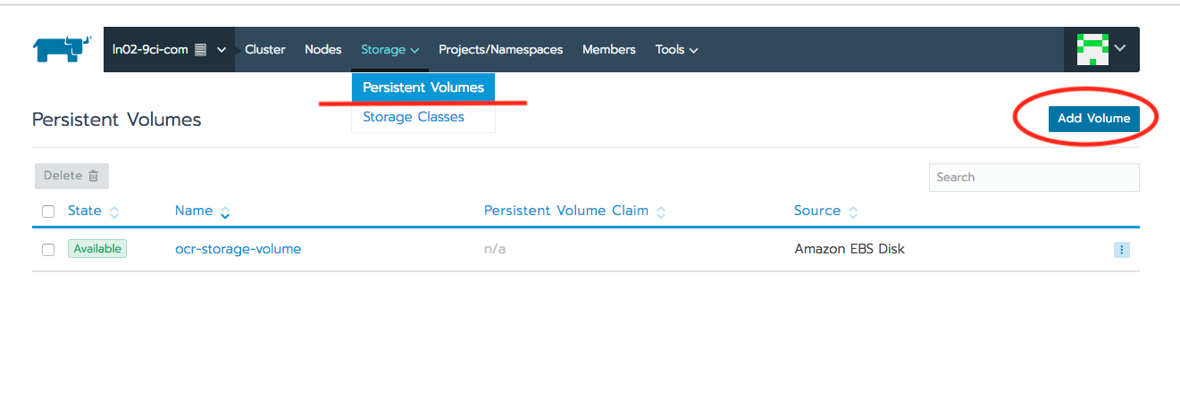

1. Setup values and save

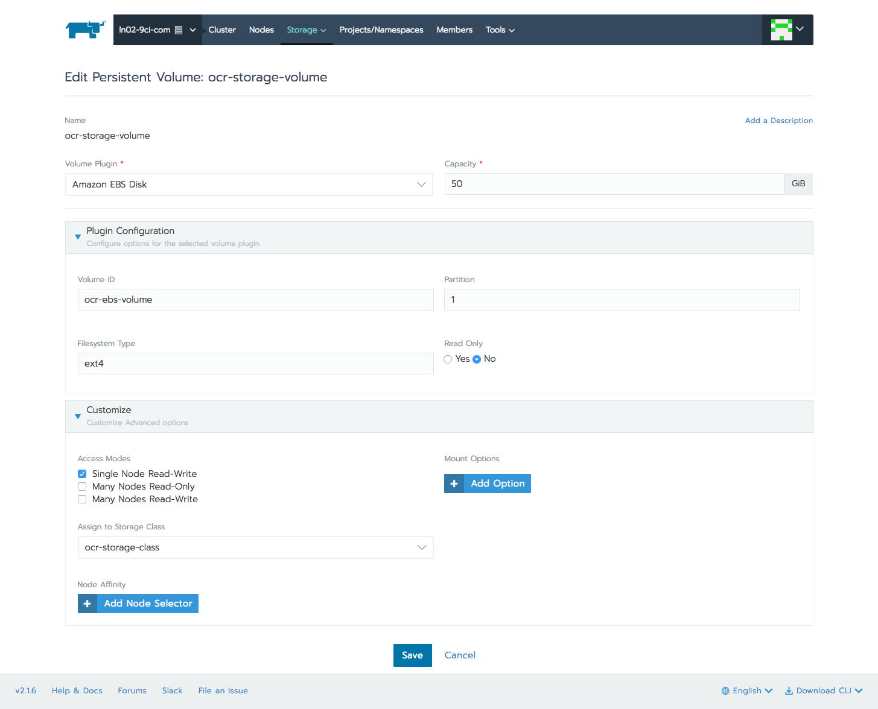

# **Create project and namespace**

## Create a project

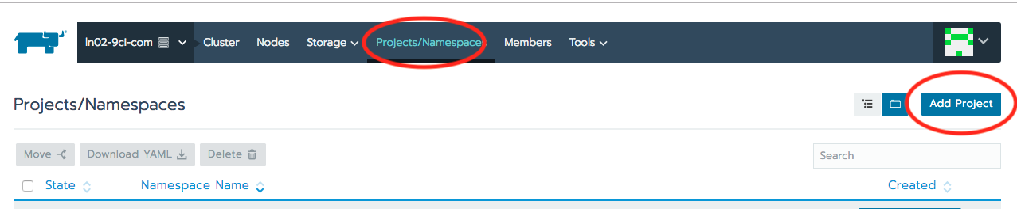

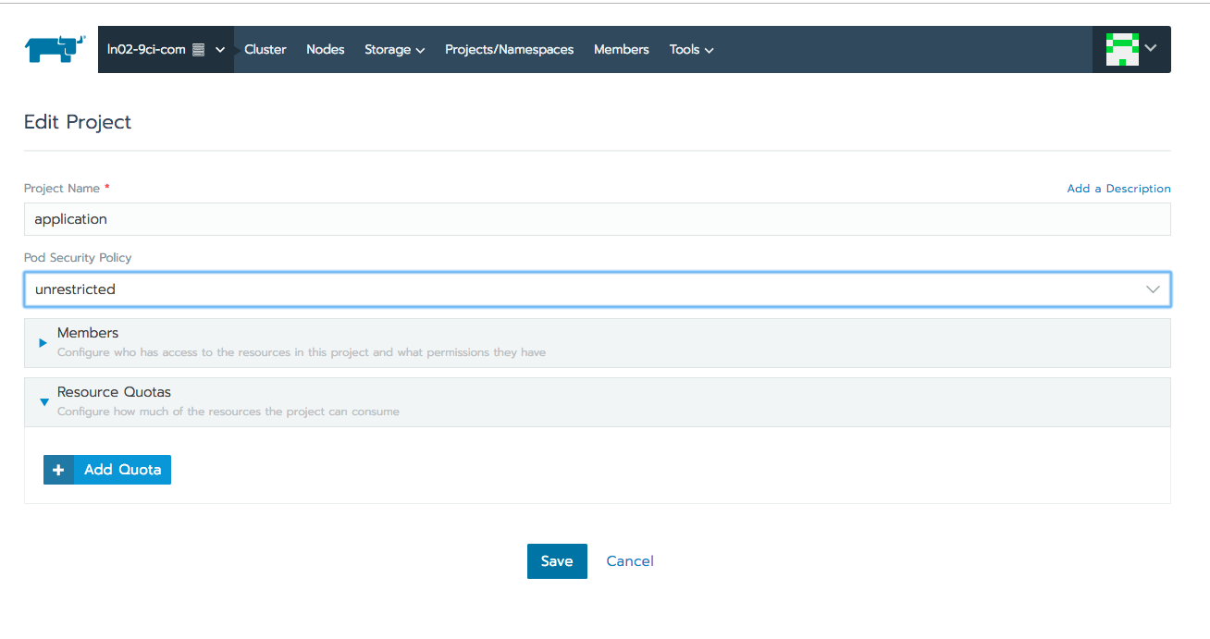

## Create a namespace

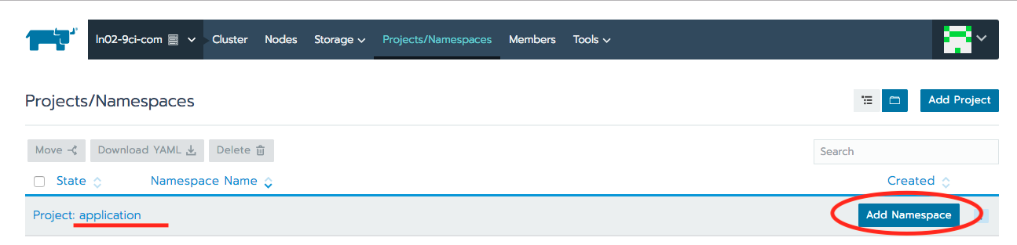

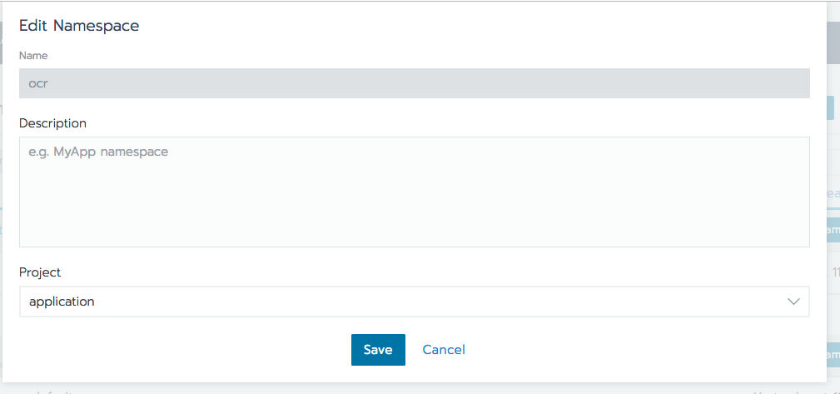

# **Select namespace of the cluster**

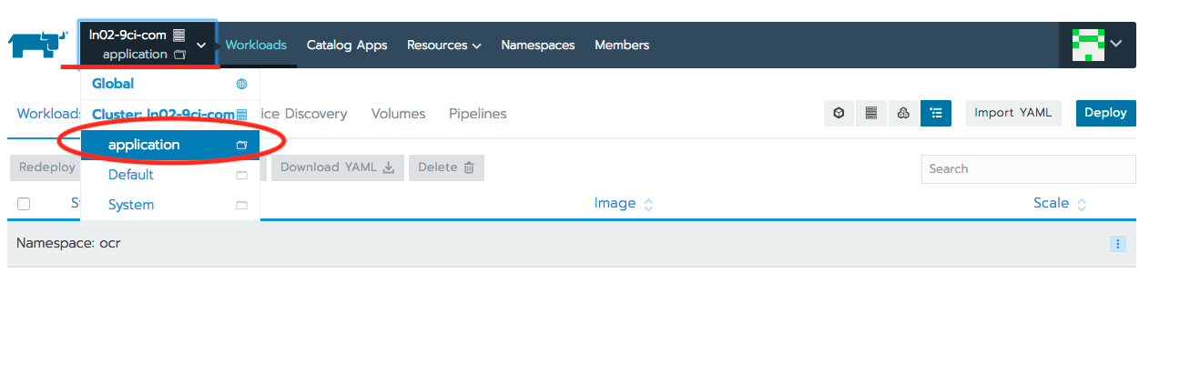

# **Create a volume for pods**

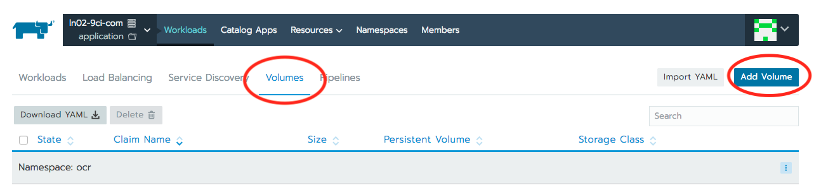

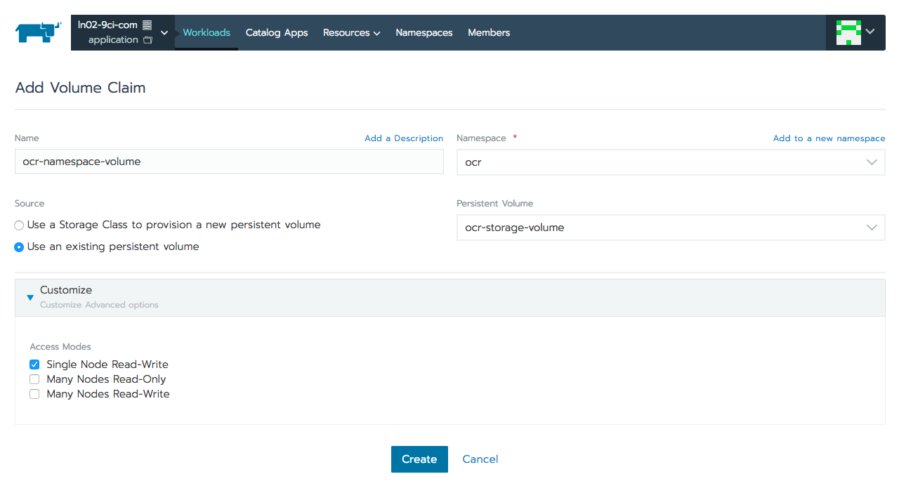

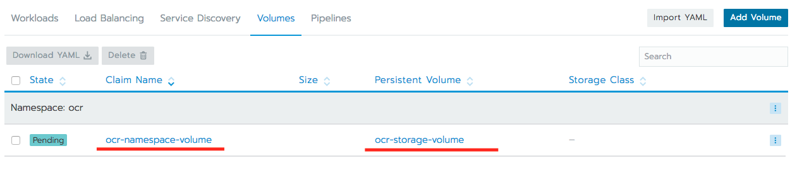

# **Create workload**

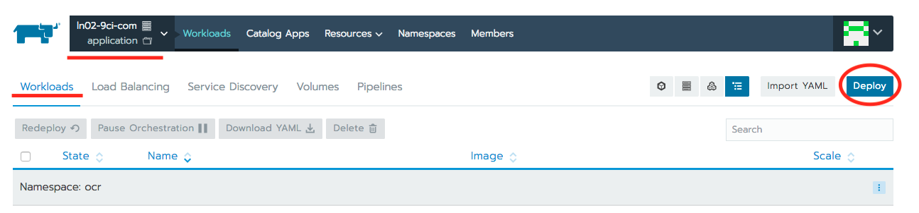

# 

In Docker Image field, you must enter a docker repository of app to deploy

# **Check workload and View detail status**

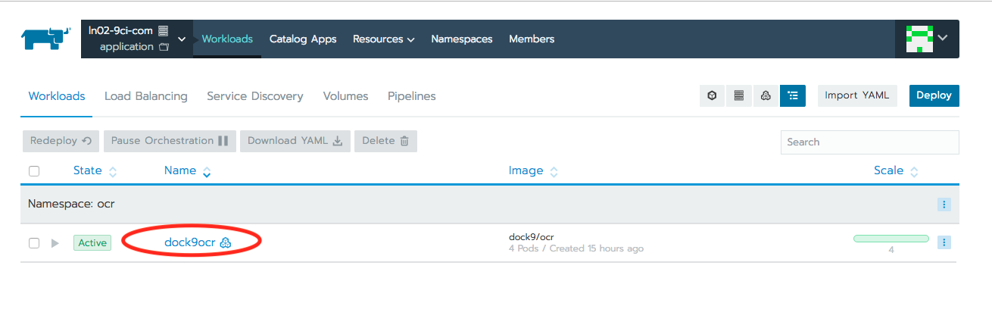

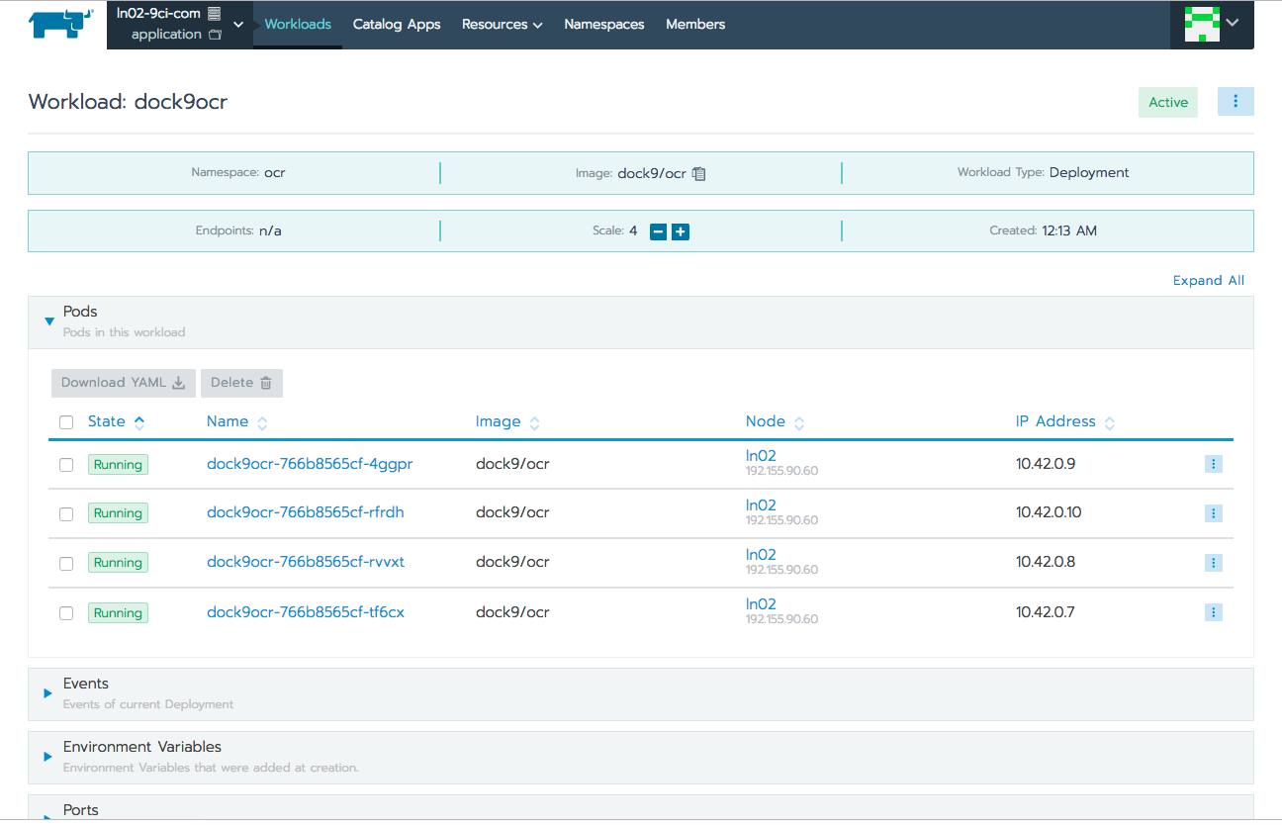

# **View log of each pod**

